EXPERIMENT 14
Aim:To develop a flowchart in Figma explaining the operation of General Packet Radio Service (GPRS).
Procedure:
• Open Figma and create a new design file.
• Create a frame for the flowchart.
• Add a Start symbol at the top.
• Add boxes showing the GPRS operation steps, such as mobile station connection, network authentication, data packet transmission, and data delivery.
• Add arrows to connect the steps in the correct order.
• Include the main GPRS components, such as MS, SGSN, and GGSN.
• Use different colors and labels to make the flowchart easy to understand.
• Arrange all elements neatly and check the flow of the diagram.
OUTPUT:
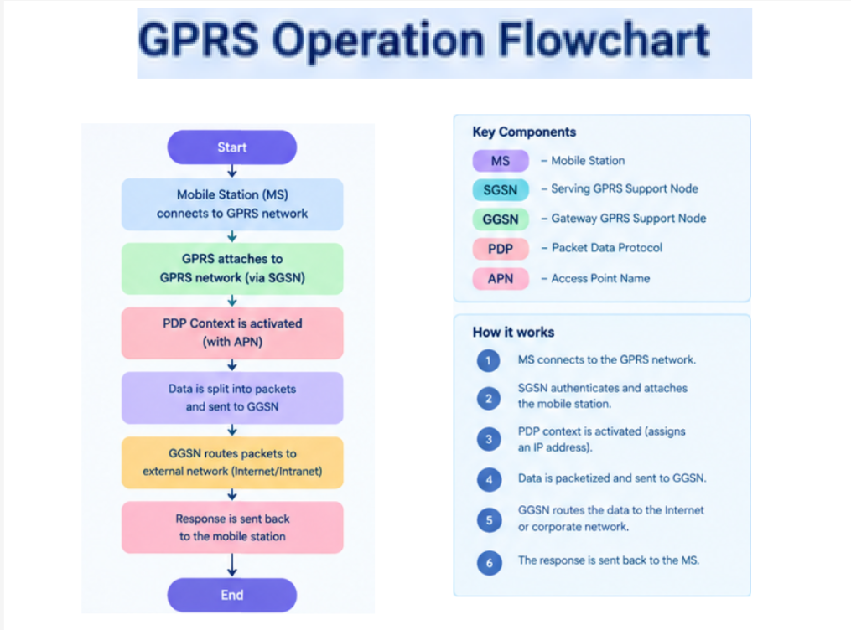

FIGMALINK: https://www.figma.com/design/ED1qcVpNfWi2Zuft4amJyZ/Untitled?node-id=69-161&t=zih8IyL283jodQsH-0

RESULT:The operation of General Packet Radio Service (GPRS) was successfully explained using a flowchart designed in Figma.

